EXPT NO: 3 | IMPLEMENTATION OF CONVOLUTIONAL NEURAL NETWORKS (CNNs) FOR IMAGE CLASSIFICATION
DATE:

Midhun P 24BAD069

PRE-LAB QUESTIONS (PROVIDE BRIEF ANSWERS TO THE FOLLOWING QUESTIONS)
- What is a Convolutional Neural Network (CNN)?

A Convolutional Neural Network (CNN) is a type of deep learning model specifically designed to process structured grid data such as images. It consists of multiple layers including convolutional layers, pooling layers, and fully connected layers. CNNs automatically learn spatial hierarchies of features from input images using shared weights and local connectivity, making them highly efficient for image recognition and classification tasks.

- What are the functions of convolution and pooling layers in a CNN?

The convolutional layer applies learnable filters (kernels) across the input image to extract local features such as edges, textures, and shapes by computing element-wise dot products. It preserves the spatial relationships between pixels. The pooling layer (typically Max Pooling) reduces the spatial dimensions of the feature maps, which decreases computational complexity, controls overfitting, and makes the representation more robust to small translations and distortions in the input.

- Differentiate between image classification and object detection.

Image classification assigns a single label to an entire image (e.g., "cat" or "dog"), indicating the dominant object or scene present. Object detection, on the other hand, identifies and localizes multiple objects within an image by drawing bounding boxes around each detected object and labeling them. Classification answers "what is in the image," while object detection answers "what is in the image and where."

- Why is image preprocessing important before training a CNN model?

Image preprocessing is essential to ensure consistent input to the CNN model. Resizing standardizes image dimensions so all inputs have the same shape. Normalization (scaling pixel values to [0,1] or [-1,1]) speeds up convergence and prevents large pixel values from dominating the learning process. Preprocessing also helps remove noise, reduces class imbalance effects, and can improve generalization through data augmentation techniques such as flipping, rotation, and cropping.

- What are the advantages of using benchmark datasets such as CIFAR-10 or Kaggle image datasets.
Benchmark datasets such as CIFAR-10 and Kaggle datasets offer several advantages: (1) They are well-curated, labeled, and ready to use, reducing data preparation time. (2) They enable fair comparison of different models and algorithms on a standard basis. (3) They are widely accepted by the research community, making results reproducible and verifiable. (4) They provide diverse and balanced samples across multiple classes, which helps in building robust and generalizable CNN models.

AIM
To design, implement, and evaluate a Convolutional Neural Network (CNN) for image classification using a benchmark image dataset.

SOFTWARE REQUIREMENTS
- Python
- TensorFlow/Keras or PyTorch
- Google Colab
- Matplotlib
- Kaggle Dataset (e.g., CIFAR-10, Cats vs Dogs, Intel Image Classification)

OBJECTIVES
Students will be able to:
- Understand the architecture of Convolutional Neural Networks.
- Implement a CNN model for image classification.
- Train and evaluate a CNN using a real-world image dataset.
- Visualize training and validation performance.
- Analyze the effectiveness of CNNs for image recognition tasks.

Task A: DATASET PREPARATION
- Perform the following tasks:
- Download an image dataset from Kaggle or use CIFAR-10.
- Load the dataset.
- Preprocess images by resizing and normalization.
- Split the dataset into training, validation, and testing sets.
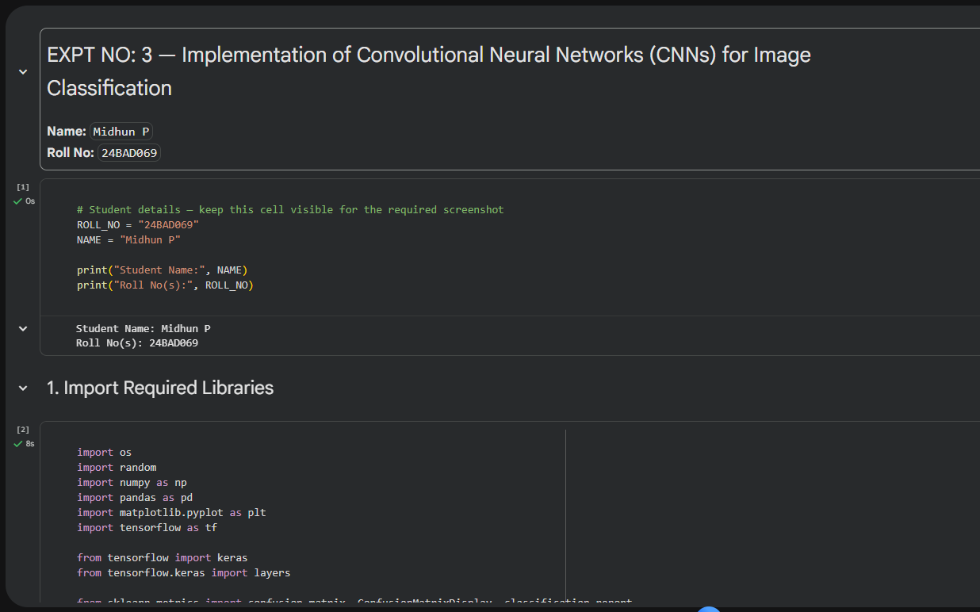
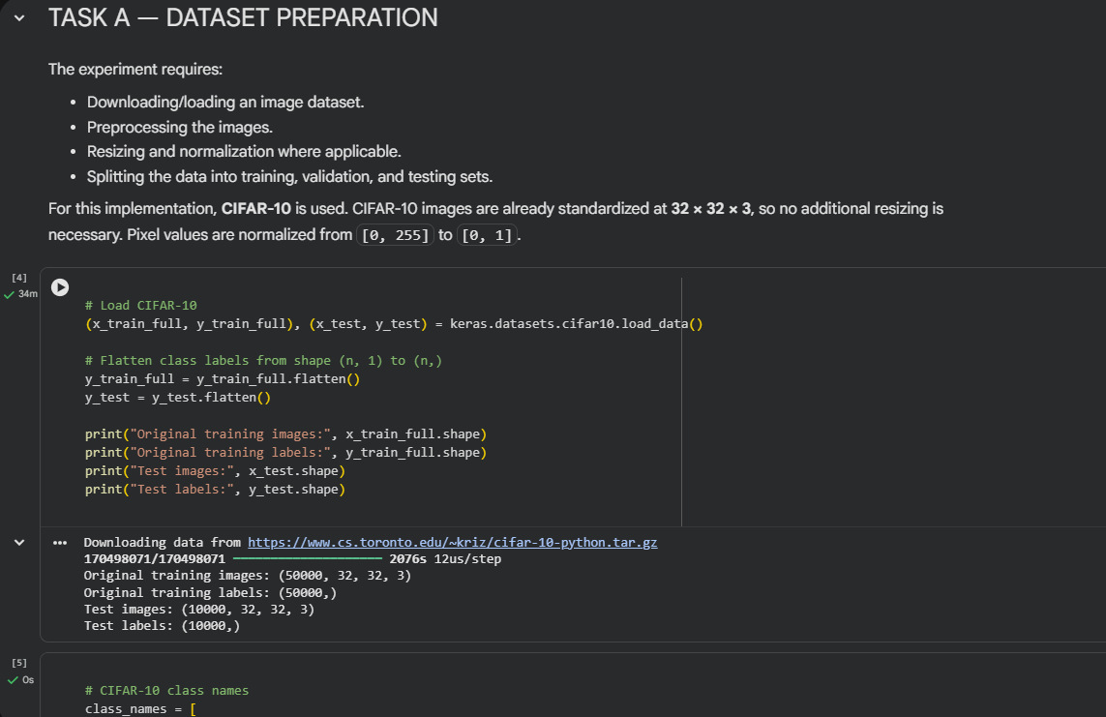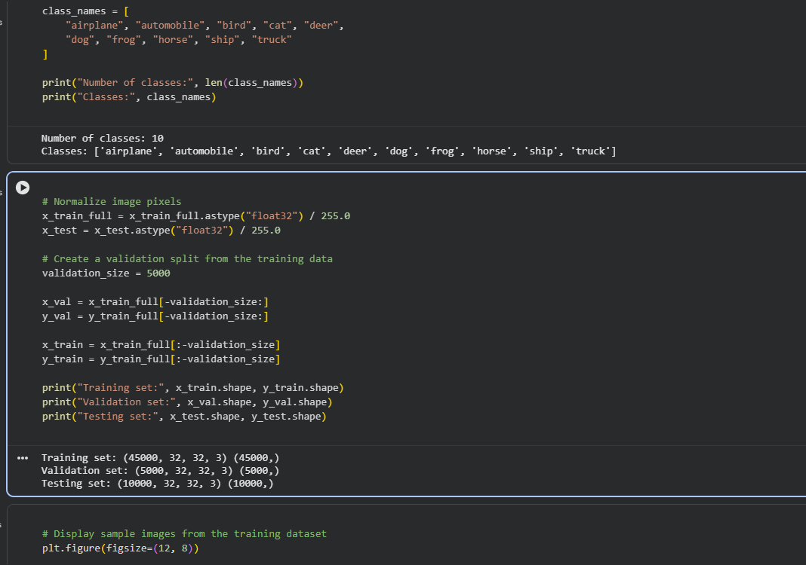

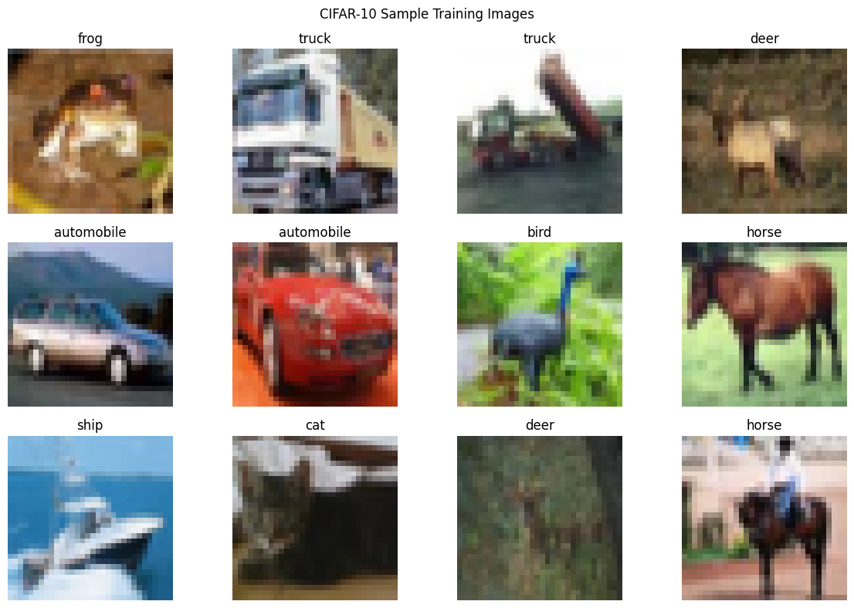

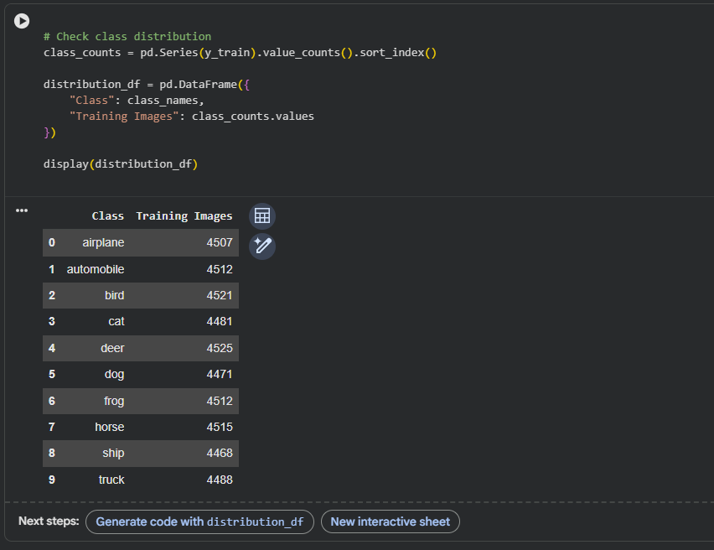

Task B: CNN MODEL IMPLEMENTATION
Build a CNN model consisting of:
- Convolution layers
- ReLU activation
- Max Pooling layers
- Fully Connected layers
- Softmax output layer

Compile the model using:
- Appropriate optimizer
- Cross-entropy loss function

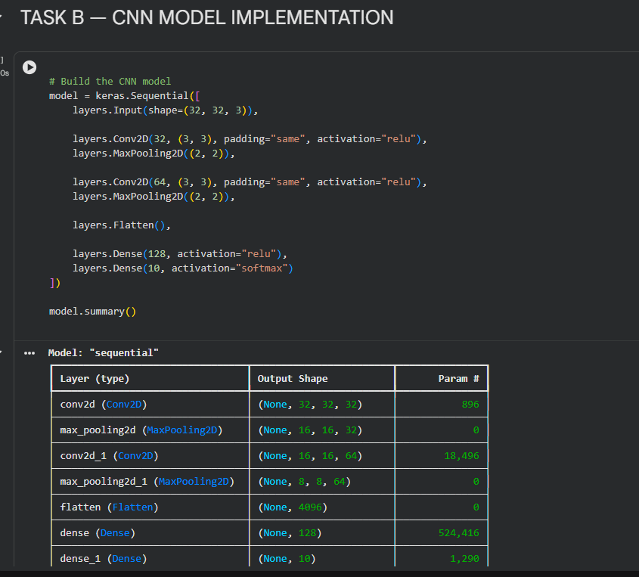
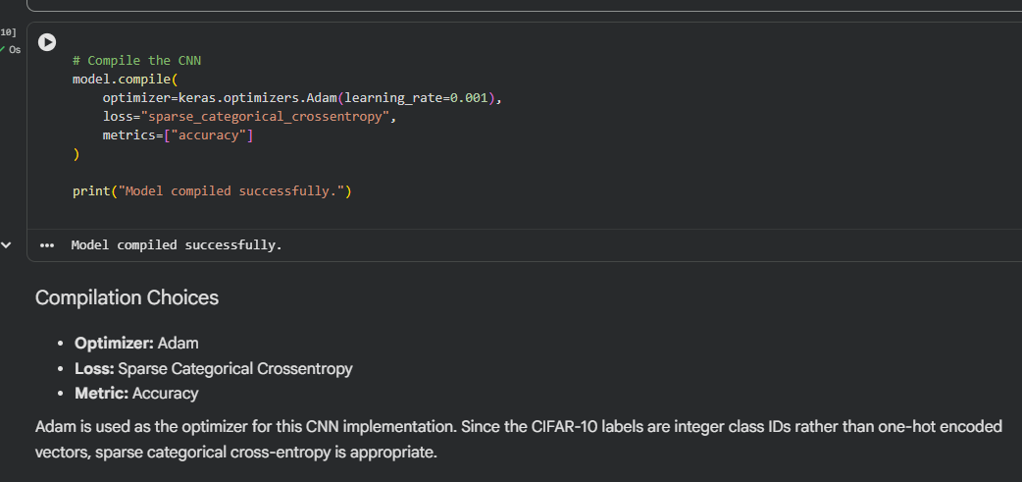
Task C: MODEL TRAINING AND EVALUATION
Train the CNN model.
Record:
- Training accuracy
- Validation accuracy
- Training loss
- Validation loss
- Testing accuracy
Plot:
- Accuracy vs Epoch
- Loss vs Epoch

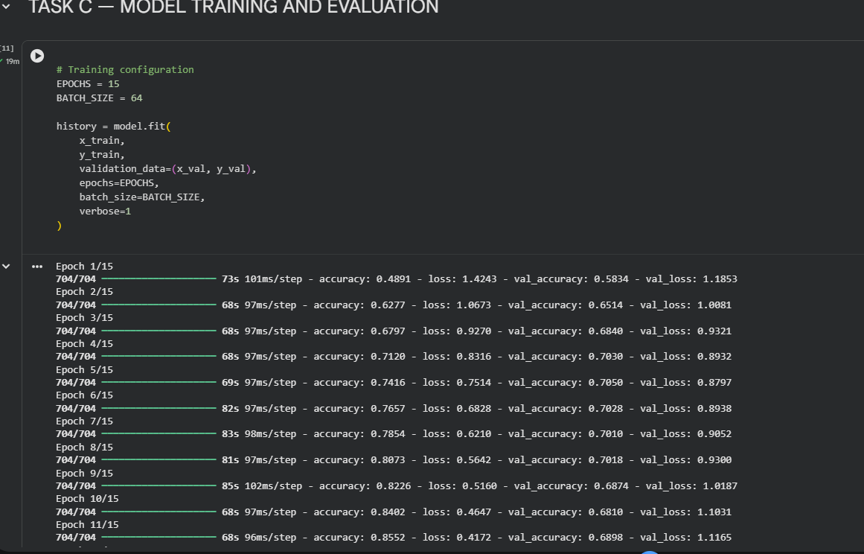
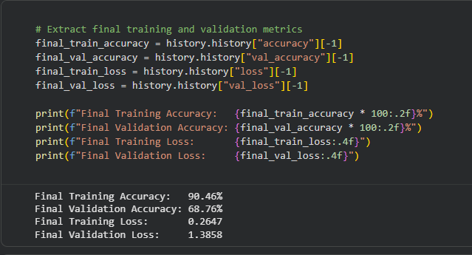
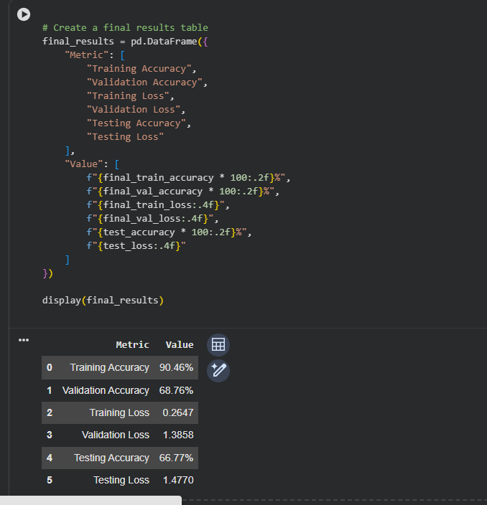

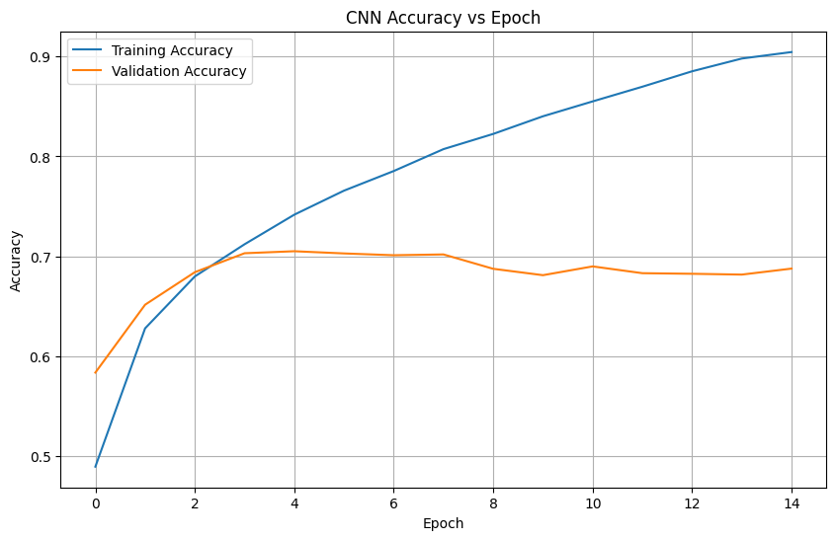
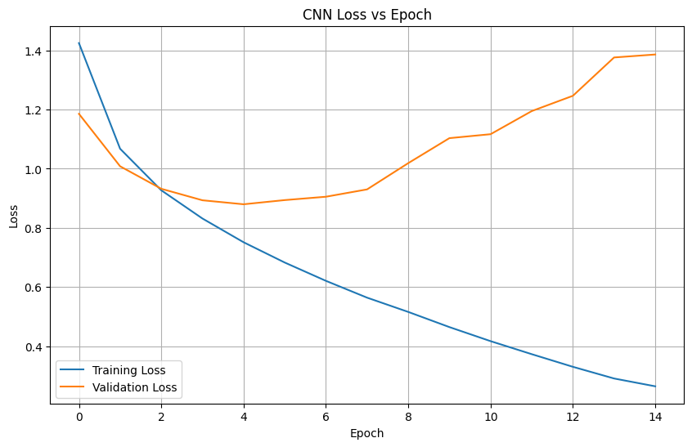

Task D: PERFORMANCE ANALYSIS
Analyze:
- Classification accuracy
- Confusion Matrix
- Sample predictions
- Misclassified images
Discuss the strengths and limitations of CNNs for image classification.

(CODE: CONATAINS STUDENT ROLL NOS
SCREENSHOT OF CODE
SCREENSHOT OF OUTPUT)

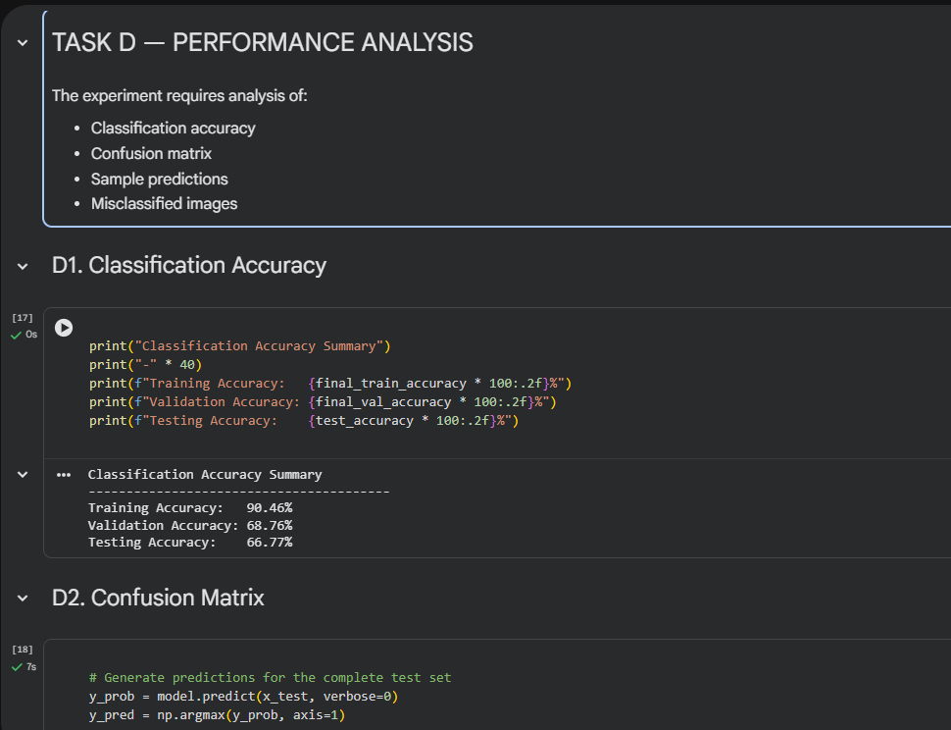
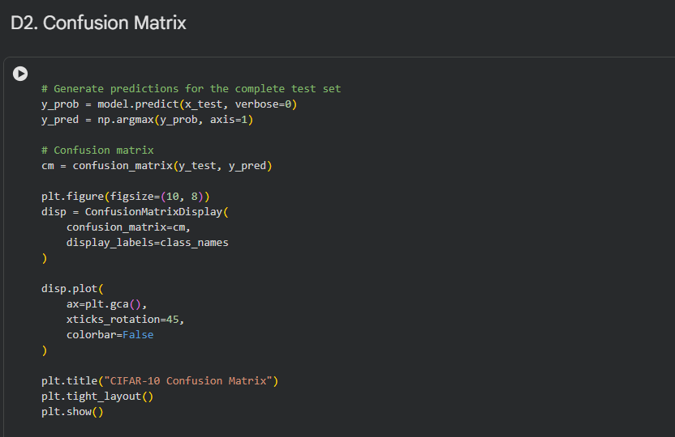

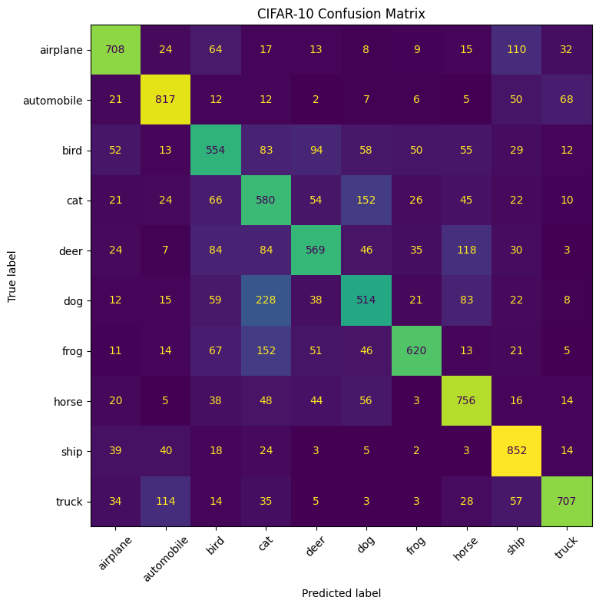

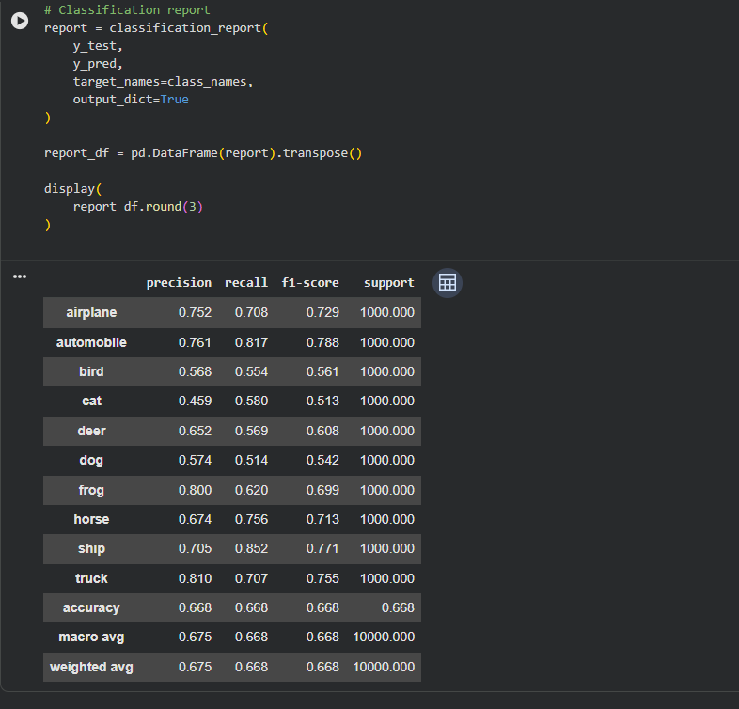
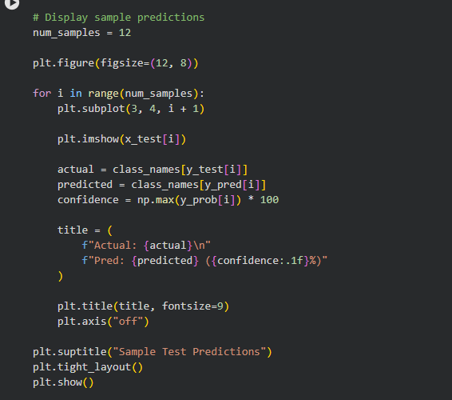

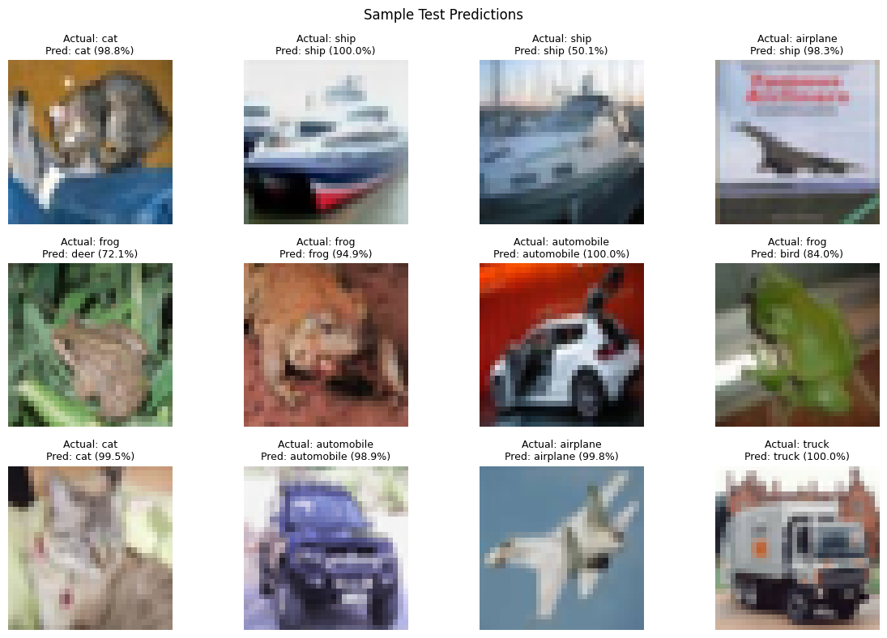

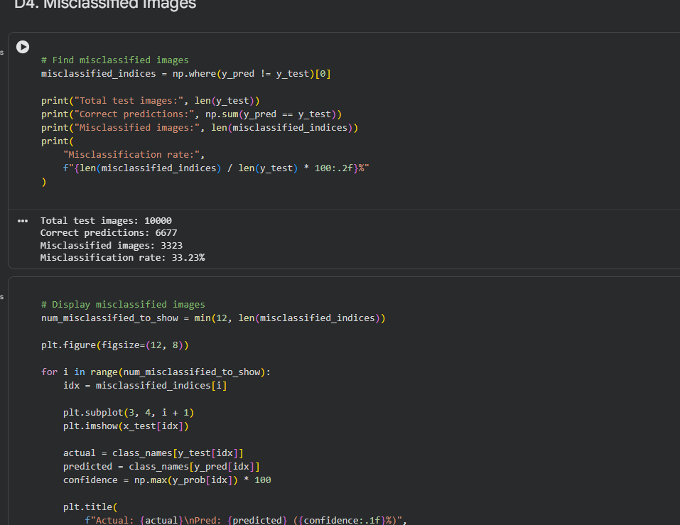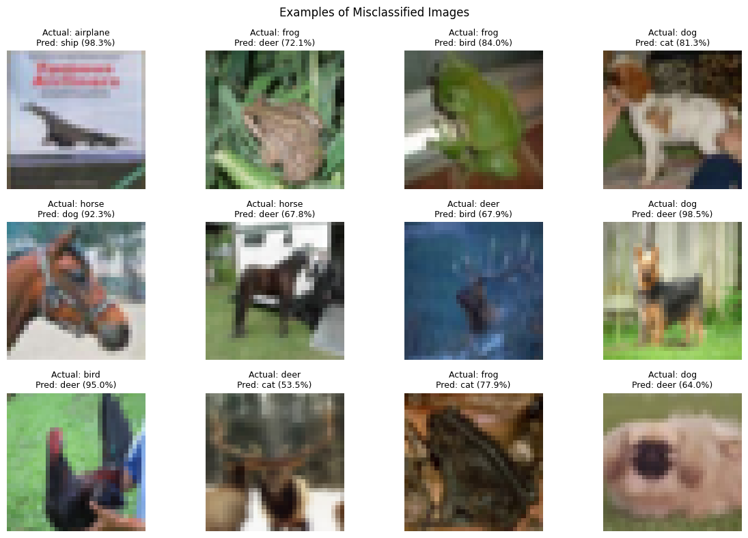

Task D: PERFORMANCE ANALYSIS
Analyze:
- Classification accuracy
- Confusion Matrix
- Sample predictions
- Misclassified images
Discuss the strengths and limitations of CNNs for image classification.

(CODE: CONATAINS STUDENT ROLL NOS
SCREENSHOT OF CODE
SCREENSHOT OF OUTPUT)

POST-LAB QUESTIONS (PROVIDE BRIEF ANSWERS TO THE FOLLOWING QUESTIONS)
- Why are convolution layers more effective than fully connected layers for image processing?

Convolution layers exploit local connectivity and weight sharing, meaning the same filter is applied across the entire image. This drastically reduces the number of parameters compared to fully connected layers, which connect every neuron to every input pixel. For a 32x32x3 image, a fully connected layer would require tens of thousands of weights per neuron, making it computationally expensive and prone to overfitting. Convolution layers also preserve spatial structure, enabling the model to detect features such as edges and textures regardless of their position in the image.

- How does Max Pooling improve CNN performance?

Max Pooling selects the maximum value from each patch of the feature map, which reduces the spatial dimensions while retaining the most dominant features. This improves CNN performance in three key ways: (1) It reduces the number of parameters and computations in deeper layers, making training faster. (2) It introduces a degree of translational invariance, so the model can recognize features even when they shift slightly in position. (3) It helps prevent overfitting by providing an abstracted form of the feature maps, reducing sensitivity to exact pixel locations.

- Which hyperparameters significantly affected your CNN model performance?

Several hyperparameters significantly influenced the model performance: (1) Learning rate – a high learning rate caused unstable training while a lower value (0.001) led to smooth convergence. (2) Number of epochs – too few epochs caused underfitting; increasing epochs improved accuracy but risked overfitting. (3) Batch size – smaller batch sizes provided better generalization but were slower to train. (4) Number of filters and kernel size – more filters captured richer features. (5) Dropout rate – adding dropout (0.5) helped reduce overfitting and improved validation accuracy.

- What challenges did you encounter while training the CNN model?

The main challenges encountered during CNN model training included: (1) Overfitting – the model achieved high training accuracy but lower validation accuracy, which was addressed using dropout and data augmentation. (2) Long training time – training on large image datasets required significant computational resources; GPU acceleration in Google Colab helped overcome this. (3) Class imbalance – some classes had fewer samples, leading to biased predictions, which was managed through balanced sampling. (4) Hyperparameter tuning – finding the optimal combination of learning rate, epochs, and filters required multiple experimental runs.

- Suggest two improvements that can increase the classification accuracy of your CNN.

Two improvements to increase classification accuracy are: (1) Transfer Learning – Using a pre-trained model such as VGG16, ResNet50, or MobileNet (trained on ImageNet) and fine-tuning it on the target dataset can significantly boost accuracy, especially when the training data is limited. These models have already learned powerful feature representations. (2) Data Augmentation – Applying transformations such as random flipping, rotation, zoom, brightness adjustment, and cropping to the training images artificially increases dataset diversity. This helps the model generalize better to unseen data and reduces overfitting.

ASSESSMENT
Description | Max Marks | Marks Awarded
Pre Lab Exercise | 5
In Lab Exercise | 10
Post Lab Exercise | 5
Viva | 10
Total | 30
Faculty Signature

